**heel_strike_loc**

**OBJECTIVE**

Detect heel strike(s) location from raw accelerometer signals

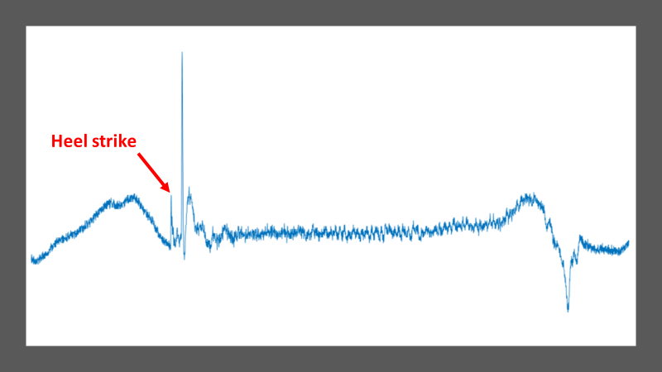

**Figure 1:** Example of a typical raw accelerometer signal obtained during a single walking step. The heel strike location is indicated by a red arrow.

**IN/OUT**

function [numSteps, hsLoc] = heel_strike_loc(signal, samplingFrequency, window1, window2)

**Inputs:**

* **signal:** raw accelerometer signal (matrix size m x 1)
* **samplingFrequency:** frequency at which the signal was captured (in Hz)
* **window1:** number of data points included in the centralized frames (before and after main peaks, default: 500; might need to be smaller for faster signals, e.g. running)
* **window2:** number of data points included in the window before each main peak (default: 100; might need to be smaller for faster signals, e.g. running)

**Outputs:**

* **numSteps:** number of steps recorded by the accelerometer (- 2 as the first and last step are not counted)
* **hsLoc:** vector including the indexes of each detected heel strike on the raw accelerometer signal

**METHODS**

The code is structured in 3 different steps:

**STEP 1:** Low pass filtering and number of steps

1. Apply strong low pass filter to obtain a sinusoidal signal (Figure 2)

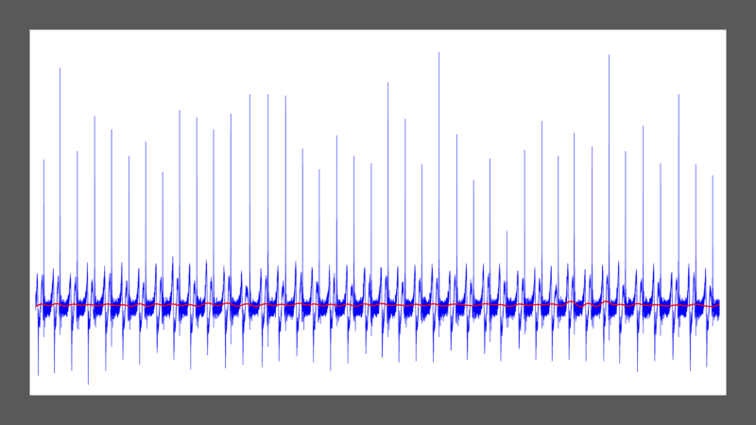

**Figure 2:** Raw accelerometer data (blue) and corresponding low pass filtered signal (red).

1. Calculate the number of steps using the number of peaks calculated on the filtered signal

**STEP 2:** Main peaks detection

1. Divides the raw signal into frames (one frame per step)
2. Calculates the location of the main peak on each frame (Figure 3)

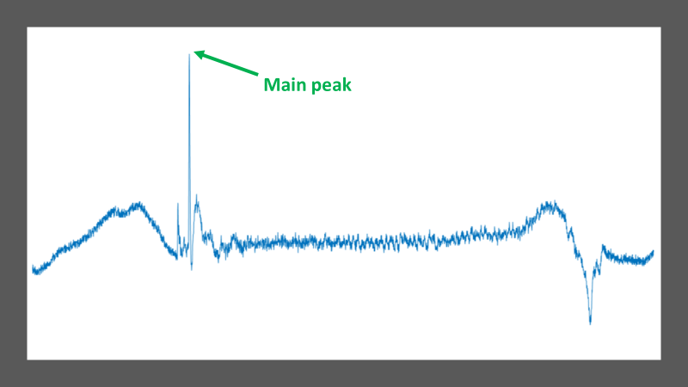

**Figure 3:** Example of a single frame isolated from the whole raw accelerometer signal. The detected main peak is indicated by a green arrow.

**STEP 3:** Heel strike detection

1. Creates new frames centralized on every main peak detected (includes X1 data points before and after the main peak, defined by variable *window1*)
2. Calculates the location of every minor peak within a window of X2 data points (defined by variable *window2*) before the main peak
3. Calculates the location of the max of the minor peaks (= heel strike, Figure 4)

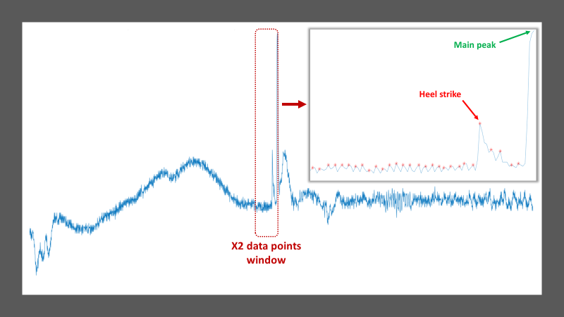

**Figure 4:** Example of a new frame centralized on the main peak. The window of X2 data points is shown in red, along with the correspond calculated peaks and heel strike location (in red).